**SQL ASSIGNMENT**

***TASK -1: Generate a random data input file***

*a) Feed-1, which has 10 columns with 10 rows,*

*b) Feed-2, which has 15 columns with 15 rows,*

*c) Feed-3, which has 20 columns with 20 rows*

----------------------------------------------------------------------------------------------------------------------------------------------

**FEED-1 QUERY AND OUTPUT BELOW**

CREATE TABLE feed1 (

col_1 INT,

col_2 VARCHAR(255),

col_3 VARCHAR(255),

col_4 VARCHAR(255),

col_5 VARCHAR(255),

col_6 VARCHAR(255),

col_7 VARCHAR(255),

col_8 VARCHAR(255),

col_9 VARCHAR(255),

col_10 VARCHAR(255)

);

-- Insert 10 random rows

INSERT INTO feed1 (col_1, col_2, col_3, col_4, col_5, col_6, col_7, col_8, col_9, col_10)

SELECT

g.n,

substr(md5(random()::text), 1, 8),

substr(md5(random()::text), 1, 8),

substr(md5(random()::text), 1, 8),

substr(md5(random()::text), 1, 8),

substr(md5(random()::text), 1, 8),

substr(md5(random()::text), 1, 8),

substr(md5(random()::text), 1, 8),

substr(md5(random()::text), 1, 8),

substr(md5(random()::text), 1, 8)

FROM generate_series(1,10) AS g(n);

-- Duplicate one row (take the first row and insert again)

INSERT INTO feed1

SELECT *

FROM feed1

OFFSET 0 LIMIT 1;

select * from feed1 ;

OUTPUT BELOW

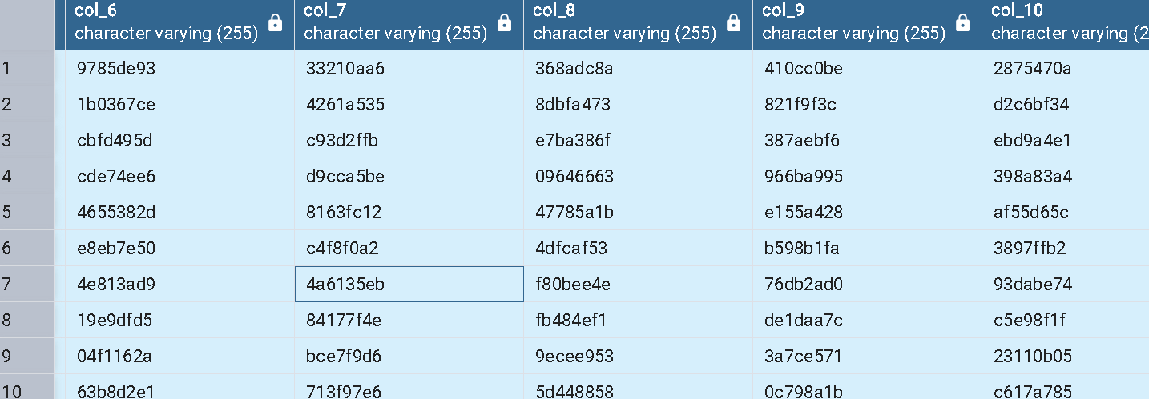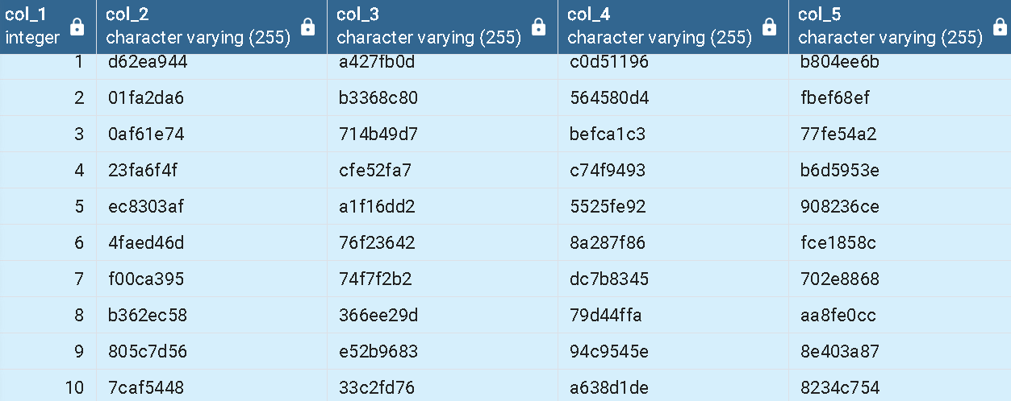

--------------------------------------------------------------------------------------------------------------------------------------------------------------------------

**FEED-2 QUERY AND OUTPUT BELOW**

INSERT INTO Feed2 (col_1, col_2, col_3, col_4, col_5, col_6, col_7, col_8, col_9, col_10,

col_11, col_12, col_13, col_14, col_15)

SELECT

g.n,

SUBSTRING(MD5(RANDOM()::text), 1, 8),

SUBSTRING(MD5(RANDOM()::text), 1, 8),

SUBSTRING(MD5(RANDOM()::text), 1, 8),

SUBSTRING(MD5(RANDOM()::text), 1, 8),

SUBSTRING(MD5(RANDOM()::text), 1, 8),

SUBSTRING(MD5(RANDOM()::text), 1, 8),

SUBSTRING(MD5(RANDOM()::text), 1, 8),

SUBSTRING(MD5(RANDOM()::text), 1, 8),

SUBSTRING(MD5(RANDOM()::text), 1, 8),

SUBSTRING(MD5(RANDOM()::text), 1, 8),

SUBSTRING(MD5(RANDOM()::text), 1, 8),

SUBSTRING(MD5(RANDOM()::text), 1, 8),

SUBSTRING(MD5(RANDOM()::text), 1, 8),

SUBSTRING(MD5(RANDOM ()::text), 1, 8)

FROM generate_series(1, 15) g(n);

-- Duplicate first 2 rows (like LIMIT 2 in MySQL)

INSERT INTO Feed2

SELECT * FROM Feed2

WHERE col_1 IN (1, 2);

SELECT * FROM FEED2

DROP TABLE IF EXISTS Feed3;

CREATE TABLE Feed3 (

col_1 INT,

col_2 VARCHAR(255), col_3 VARCHAR(255), col_4 VARCHAR(255), col_5 VARCHAR(255),

col_6 VARCHAR(255), col_7 VARCHAR(255), col_8 VARCHAR(255), col_9 VARCHAR(255), col_10 VARCHAR(255),

col_11 VARCHAR(255), col_12 VARCHAR(255), col_13 VARCHAR(255), col_14 VARCHAR(255), col_15 VARCHAR(255),

col_16 VARCHAR(255), col_17 VARCHAR(255), col_18 VARCHAR(255), col_19 VARCHAR(255), col_20 VARCHAR(255)

);

-- Insert 20 rows with random values

INSERT INTO Feed3 (col_1, col_2, col_3, col_4, col_5, col_6, col_7, col_8, col_9, col_10,

col_11, col_12, col_13, col_14, col_15, col_16, col_17, col_18, col_19, col_20)

SELECT

g.n,

SUBSTRING(MD5(RANDOM()::text), 1, 8), -- col_2

SUBSTRING(MD5(RANDOM()::text), 1, 8), -- col_3

SUBSTRING(MD5(RANDOM()::text), 1, 8), -- col_4

SUBSTRING(MD5(RANDOM()::text), 1, 8), -- col_5

SUBSTRING(MD5(RANDOM()::text), 1, 8), -- col_6

SUBSTRING(MD5(RANDOM()::text), 1, 8), -- col_7

SUBSTRING(MD5(RANDOM()::text), 1, 8), -- col_8

SUBSTRING(MD5(RANDOM()::text), 1, 8), -- col_9

SUBSTRING(MD5(RANDOM()::text), 1, 8), -- col_10

SUBSTRING(MD5(RANDOM()::text), 1, 8), -- col_11

SUBSTRING(MD5(RANDOM()::text), 1, 8), -- col_12

SUBSTRING(MD5(RANDOM()::text), 1, 8), -- col_13

SUBSTRING(MD5(RANDOM()::text), 1, 8), -- col_14

SUBSTRING(MD5(RANDOM()::text), 1, 8), -- col_15

SUBSTRING(MD5(RANDOM()::text), 1, 8), -- col_16

SUBSTRING(MD5(RANDOM()::text), 1, 8), -- col_17

SUBSTRING(MD5(RANDOM()::text), 1, 8), -- col_18

SUBSTRING(MD5(RANDOM()::text), 1, 8), -- col_19

SUBSTRING(MD5(RANDOM()::text), 1, 8) -- col_20

FROM generate_series(1, 20) g(n);

INSERT INTO Feed3 (col_1, col_2, col_3, col_4, col_5, col_6, col_7, col_8, col_9, col_10,

col_11, col_12, col_13, col_14, col_15, col_16, col_17, col_18, col_19, col_20)

SELECT

(SELECT MAX(col_1) FROM Feed3) + ROW_NUMBER() OVER(),

col_2, col_3, col_4, col_5, col_6, col_7, col_8, col_9, col_10,

col_11, col_12, col_13, col_14, col_15, col_16, col_17, col_18, col_19, col_20

FROM Feed3

WHERE col_1 IN (1, 2);

SELECT * FROM FEED3

-----------------------------------------------------------------------------------------------------------------------------------------------------------------------

**TASK -2**

***Automate the Rea 1 input file generation using SQL scripts, and the parameter will be "Feed name* & Number of Rows to populate Data***

CREATE OR REPLACE PROCEDURE generate_feed(

table_name TEXT,

num_cols INT,

num_rows INT

)

LANGUAGE plpgsql

AS $$

DECLARE

i INT;

j INT;

create_table_sql TEXT;

col_list TEXT := '';

val_list TEXT;

BEGIN

-- Drop table if exists

EXECUTE format('DROP TABLE IF EXISTS %I', table_name);

-- Build CREATE TABLE dynamically

create_table_sql := 'CREATE TABLE ' || quote_ident(table_name) || ' (';

FOR i IN 1..num_cols LOOP

create_table_sql := create_table_sql || 'col_' || i || ' VARCHAR(255)';

IF i < num_cols THEN

create_table_sql := create_table_sql || ', ';

END IF;

END LOOP;

create_table_sql := create_table_sql || ')';

EXECUTE create_table_sql;

-- Build column list

col_list := '';

FOR i IN 1..num_cols LOOP

col_list := col_list || 'col_' || i;

IF i < num_cols THEN

col_list := col_list || ', ';

END IF;

END LOOP;

-- Insert rows

FOR j IN 1..num_rows LOOP

val_list := '';

FOR i IN 1..num_cols LOOP

val_list := val_list || quote_literal(substr(md5(random()::text), 1, 8));

IF i < num_cols THEN

val_list := val_list || ', ';

END IF;

END LOOP;

EXECUTE 'INSERT INTO ' || quote_ident(table_name) || '(' || col_list || ') VALUES (' || val_list || ')';

END LOOP;

-- Duplicate first row if rows exist

IF num_rows > 0 THEN

EXECUTE 'INSERT INTO ' || quote_ident(table_name) || '(' || col_list || ') ' ||

'SELECT ' || col_list || ' FROM ' || quote_ident(table_name) || ' LIMIT 1';

END IF;

RAISE NOTICE 'Table % created and populated with % rows and % columns.', table_name, num_rows, num_cols;

END;

$$;

**CALL generate_feed('feed3', 20, 20);**

**REQ 3,4 Write SQL script to identify the duplicate (rows) in each of the table Feed-1, 2, 3**

**Write the duplicate records in output file - "duplicates"**

CREATE TABLE IF NOT EXISTS duplicates (

table_name_source VARCHAR(255),

count_of_duplicates INT,

col_1 VARCHAR(255), col_2 VARCHAR(255), col_3 VARCHAR(255), col_4 VARCHAR(255), col_5 VARCHAR(255),

col_6 VARCHAR(255), col_7 VARCHAR(255), col_8 VARCHAR(255), col_9 VARCHAR(255), col_10 VARCHAR(255),

col_11 VARCHAR(255), col_12 VARCHAR(255), col_13 VARCHAR(255), col_14 VARCHAR(255), col_15 VARCHAR(255),

col_16 VARCHAR(255), col_17 VARCHAR(255), col_18 VARCHAR(255), col_19 VARCHAR(255), col_20 VARCHAR(255)

);

TRUNCATE TABLE duplicates;

INSERT INTO duplicates (

table_name_source, count_of_duplicates,

col_1, col_2, col_3, col_4, col_5, col_6, col_7, col_8, col_9, col_10

)

SELECT

'Feed1' AS table_name_source, COUNT(*) AS count_of_duplicates,

col_1, col_2, col_3, col_4, col_5, col_6, col_7, col_8, col_9, col_10

FROM Feed1

GROUP BY col_1, col_2, col_3, col_4, col_5, col_6, col_7, col_8, col_9, col_10

HAVING COUNT(*) > 1;

INSERT INTO duplicates (

table_name_source, count_of_duplicates,

col_1, col_2, col_3, col_4, col_5, col_6, col_7, col_8, col_9, col_10,

col_11, col_12, col_13, col_14, col_15

)

SELECT

'Feed2' AS table_name_source, COUNT(*) AS count_of_duplicates,

col_1, col_2, col_3, col_4, col_5, col_6, col_7, col_8, col_9, col_10,

col_11, col_12, col_13, col_14, col_15

FROM Feed2

GROUP BY col_1, col_2, col_3, col_4, col_5, col_6, col_7, col_8, col_9, col_10,

col_11, col_12, col_13, col_14, col_15

HAVING COUNT(*) > 1;

INSERT INTO duplicates (

table_name_source, count_of_duplicates,

col_1, col_2, col_3, col_4, col_5, col_6, col_7, col_8, col_9, col_10,

col_11, col_12, col_13, col_14, col_15, col_16, col_17, col_18, col_19, col_20

)

SELECT

'Feed3' AS table_name_source, COUNT(*) AS count_of_duplicates,

col_1, col_2, col_3, col_4, col_5, col_6, col_7, col_8, col_9, col_10,

col_11, col_12, col_13, col_14, col_15, col_16, col_17, col_18, col_19, col_20

FROM Feed3

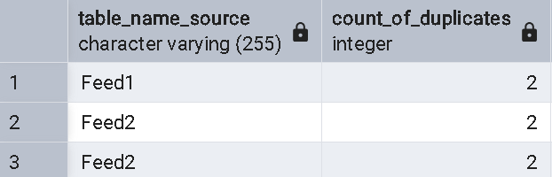GROUP BY col_1, col_2, col_3, col_4, col_5, col_6, col_7, col_8, col_9, col_10,

col_11, col_12, col_13, col_14, col_15, col_16, col_17, col_18, col_19, col_20

HAVING COUNT(*) > 1;

SELECT * FROM duplicates;

***REQ – 5 Create a script to replace all the duplicates with Unique rows and update back to the respective Feed table***

DELETE FROM Feed1 a

USING (

SELECT MIN(ctid) AS keep_ctid, col_1, col_2, col_3, col_4, col_5,

col_6, col_7, col_8, col_9, col_10

FROM Feed1

GROUP BY col_1, col_2, col_3, col_4, col_5,

col_6, col_7, col_8, col_9, col_10

HAVING COUNT(*) > 1

) b

WHERE a.col_1 = b.col_1 AND a.col_2 = b.col_2 AND a.col_3 = b.col_3 AND a.col_4 = b.col_4

AND a.col_5 = b.col_5 AND a.col_6 = b.col_6 AND a.col_7 = b.col_7 AND a.col_8 = b.col_8

AND a.col_9 = b.col_9 AND a.col_10 = b.col_10

AND a.ctid <> b.keep_ctid;

-- For Feed2 (15 columns)

DELETE FROM Feed2 a

USING (

SELECT MIN(ctid) AS keep_ctid, col_1, col_2, col_3, col_4, col_5,

col_6, col_7, col_8, col_9, col_10,

col_11, col_12, col_13, col_14, col_15

FROM Feed2

GROUP BY col_1, col_2, col_3, col_4, col_5,

col_6, col_7, col_8, col_9, col_10,

col_11, col_12, col_13, col_14, col_15

HAVING COUNT(*) > 1

) b

WHERE a.col_1 = b.col_1 AND a.col_2 = b.col_2 AND a.col_3 = b.col_3 AND a.col_4 = b.col_4

AND a.col_5 = b.col_5 AND a.col_6 = b.col_6 AND a.col_7 = b.col_7 AND a.col_8 = b.col_8

AND a.col_9 = b.col_9 AND a.col_10 = b.col_10 AND a.col_11 = b.col_11 AND a.col_12 = b.col_12

AND a.col_13 = b.col_13 AND a.col_14 = b.col_14 AND a.col_15 = b.col_15

AND a.ctid <> b.keep_ctid;

-- For Feed3 (20 columns)

DELETE FROM Feed3 a

USING (

SELECT MIN(ctid) AS keep_ctid, col_1, col_2, col_3, col_4, col_5,

col_6, col_7, col_8, col_9, col_10,

col_11, col_12, col_13, col_14, col_15,

col_16, col_17, col_18, col_19, col_20

FROM Feed3

GROUP BY col_1, col_2, col_3, col_4, col_5,

col_6, col_7, col_8, col_9, col_10,

col_11, col_12, col_13, col_14, col_15,

col_16, col_17, col_18, col_19, col_20

HAVING COUNT(*) > 1

) b

WHERE a.col_1 = b.col_1 AND a.col_2 = b.col_2 AND a.col_3 = b.col_3 AND a.col_4 = b.col_4

AND a.col_5 = b.col_5 AND a.col_6 = b.col_6 AND a.col_7 = b.col_7 AND a.col_8 = b.col_8

AND a.col_9 = b.col_9 AND a.col_10 = b.col_10 AND a.col_11 = b.col_11 AND a.col_12 = b.col_12

AND a.col_13 = b.col_13 AND a.col_14 = b.col_14 AND a.col_15 = b.col_15 AND a.col_16 = b.col_16

AND a.col_17 = b.col_17 AND a.col_18 = b.col_18 AND a.col_19 = b.col_19 AND a.col_20 = b.col_20

AND a.ctid <> b.keep_ctid;

--------------------------------------------------------------------------------------------------------------------------------------------------------------------------

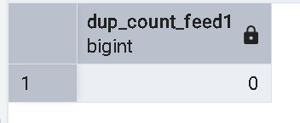***REQ – 6 Execute the duplicate script and check the output is zero***

SELECT COUNT(*) AS dup_count_feed1

FROM (

SELECT COUNT(*)

FROM Feed1

GROUP BY col_1, col_2, col_3, col_4, col_5,

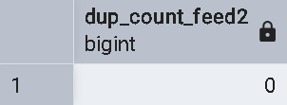 col_6, col_7, col_8, col_9, col_10

HAVING COUNT(*) > 1

) t;

SELECT COUNT(*) AS dup_count_feed2

FROM (

SELECT COUNT(*)

FROM Feed2

GROUP BY col_1, col_2, col_3, col_4, col_5,

col_6, col_7, col_8, col_9, col_10,

col_11, col_12, col_13, col_14, col_15

HAVING COUNT(*) > 1

) t;

SELECT COUNT(*) AS dup_count_feed3

FROM (

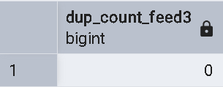 SELECT COUNT(*)

FROM Feed3

GROUP BY col_1, col_2, col_3, col_4, col_5,

col_6, col_7, col_8, col_9, col_10,

col_11, col_12, col_13, col_14, col_15,

col_16, col_17, col_18, col_19, col_20

HAVING COUNT(*) > 1

) t;

-----------------------------------------------------------------------------------------------------------------------------------------------------------------------

***Req – 7 Create SOL script to compare data from Feed-2,3 to Feed-1 and write in***

***output file on the compared results***

CREATE TABLE IF NOT EXISTS comparison_result (

source_feed VARCHAR(255),

target_feed VARCHAR(255),

record_data_col1 VARCHAR(255),

comparison_status VARCHAR(255)

);

-- Clear old results

TRUNCATE TABLE comparison_result;

-- Compare Feed2 to Feed1

INSERT INTO comparison_result (source_feed, target_feed, record_data_col1, comparison_status)

SELECT 'Feed2', 'Feed1', s.col_1, 'In source only'

FROM Feed2 s LEFT JOIN Feed1 t ON s.col_1 = t.col_1

WHERE t.col_1 IS NULL;

INSERT INTO comparison_result (source_feed, target_feed, record_data_col1, comparison_status)

SELECT 'Feed2', 'Feed1', t.col_1, 'In target only'

FROM Feed1 t LEFT JOIN Feed2 s ON t.col_1 = s.col_1

WHERE s.col_1 IS NULL;

-- Compare Feed3 to Feed1

INSERT INTO comparison_result (source_feed, target_feed, record_data_col1, comparison_status)

SELECT 'Feed3', 'Feed1', s.col_1, 'In source only'

FROM Feed3 s LEFT JOIN Feed1 t ON s.col_1 = t.col_1

WHERE t.col_1 IS NULL;

INSERT INTO comparison_result (source_feed, target_feed, record_data_col1, comparison_status)

SELECT 'Feed3', 'Feed1', t.col_1, 'In target only'

FROM Feed1 t LEFT JOIN Feed3 s ON t.col_1 = s.col_1

WHERE s.col_1 IS NULL;

SELECT * FROM comparison_result;

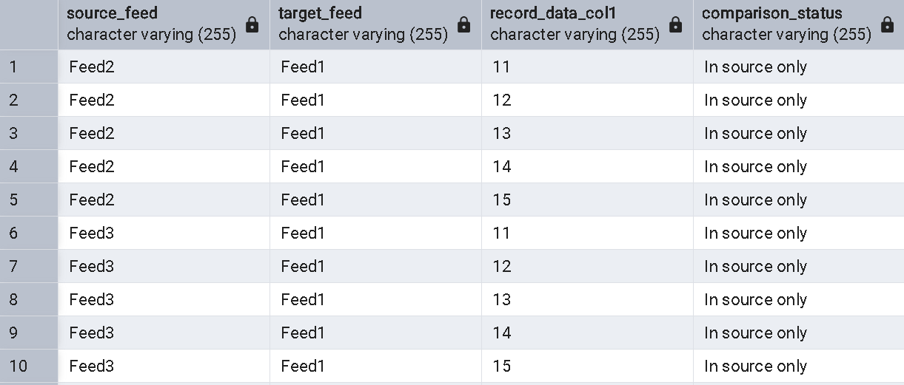

--------------------------------------------------------------------------------------------------------------------------------------------------------------------------

***Req – 8,9***

***Create a Test plan with all kinds of manual test cases to test this End***

***functionality***

***Automate the test cases (if possible) using any method, but it should be***

***Automated***

|  |  |  |  |
| --- | --- | --- | --- |
| **Test Case ID** | **Test Scenario** | **Test Steps** | **Expected Result** |
| TC-01 | Validate Feed Table Creation | Run the SQL script for Feed-1, Feed-2, Feed-3 | Tables are created with correct number of columns & rows |
| TC-02 | Validate Data Generation Automation | Execute procedure with parameters (Feed-1, 10 rows) | Data is populated with random values in correct structure |
| TC-03 | **Validate Duplicate Identification** | Execute duplicate identification script | File "duplicates" contains the expected duplicate rows |
| TC-04 | Validate Duplicate Output File | Execute duplicate identification script | File "duplicates" contains the expected duplicate rows |
| TC-05 | Validate Duplicate Removal | Run deduplication script on Feed-1 | Duplicates are removed, only unique rows remain |
| TC-06 | Verify No Duplicates Remain | Run duplicate identification script again | Query returns **zero duplicates** |
| TC-07 | Validate Data Comparison | Run comparison script between Feed-2/Feed-3 with Feed-1 | Output file contains mismatched and matched rows |
| TC-08 | End-to-End Test | Run all scripts in sequence: generate feeds → detect duplicates → remove → compare | **Entire flow works correctly without error** |
| TC-09 | Automation of task |  |  |
| TC-10 | Document the process |  |  |

Req-9

DELIMITER $$

CREATE PROCEDURE generate_feed(

IN table_name VARCHAR(255),

IN num_cols INT,

IN num_rows INT

)

BEGIN

DECLARE i INT DEFAULT 1;

DECLARE j INT DEFAULT 1;

DECLARE create_table_sql TEXT;

DECLARE insert_sql TEXT;

DECLARE col_list TEXT;

DECLARE val_list TEXT;

SET @drop_sql = CONCAT('DROP TABLE IF EXISTS ', table_name);

PREPARE stmt FROM @drop_sql;

EXECUTE stmt;

DEALLOCATE PREPARE stmt;

SET create_table_sql = CONCAT('CREATE TABLE ', table_name, ' (');

WHILE i <= num_cols DO

SET create_table_sql = CONCAT(create_table_sql, 'col_', i, ' VARCHAR(255)');

IF i < num_cols THEN

SET create_table_sql = CONCAT(create_table_sql, ', ');

END IF;

SET i = i + 1;

END WHILE;

SET create_table_sql = CONCAT(create_table_sql, ')');

SET @create_sql = create_table_sql;

PREPARE stmt FROM @create_sql;

EXECUTE stmt;

DEALLOCATE PREPARE stmt;

SET i = 1;

SET col_list = '';

WHILE i <= num_cols DO

SET col_list = CONCAT(col_list, 'col_', i);

IF i < num_cols THEN

SET col_list = CONCAT(col_list, ', ');

END IF;

SET i = i + 1;

END WHILE;

SET j = 1;

WHILE j <= num_rows DO

SET i = 1;

SET val_list = '';

WHILE i <= num_cols DO

SET val_list = CONCAT(val_list, '''', SUBSTRING(MD5(RAND()), 1, 8), '''');

IF i < num_cols THEN

SET val_list = CONCAT(val_list, ', ');

END IF;

SET i = i + 1;

END WHILE;

SET @insert_sql = CONCAT('INSERT INTO ', table_name, ' (', col_list, ') VALUES (', val_list, ')');

PREPARE stmt FROM @insert_sql;

EXECUTE stmt;

DEALLOCATE PREPARE stmt;

SET j = j + 1;

END WHILE;

IF num_rows > 0 THEN

SET @insert_sql = CONCAT('INSERT INTO ', table_name, ' (', col_list, ') SELECT ', col_list, ' FROM ', table_name, ' LIMIT 1');

PREPARE stmt FROM @insert_sql;

EXECUTE stmt;

DEALLOCATE PREPARE stmt;

END IF;

SELECT CONCAT('Table ', table_name, ' created and populated with ', num_rows, ' rows and ', num_cols, ' columns.') AS Status;

END$$

DELIMITER ;

CREATE TABLE IF NOT EXISTS duplicates (

table_name_source VARCHAR(255),

duplicate_data JSON,

count_of_duplicates INT

);

DELIMITER $$

CREATE PROCEDURE find_and_store_duplicates(IN source_table_name VARCHAR(255))

BEGIN

DECLARE done INT DEFAULT FALSE;

DECLARE cols TEXT;

DECLARE cur CURSOR FOR

SELECT GROUP_CONCAT(COLUMN_NAME)

FROM INFORMATION_SCHEMA.COLUMNS

WHERE TABLE_NAME = source_table_name AND TABLE_SCHEMA = DATABASE();

DECLARE CONTINUE HANDLER FOR NOT FOUND SET done = TRUE;

OPEN cur;

FETCH cur INTO cols;

CLOSE cur;

SET @sql = CONCAT(

'INSERT INTO duplicates (table_name_source, duplicate_data, count_of_duplicates) ',

'SELECT ''', source_table_name, ''', ',

'JSON_OBJECT(',

(SELECT GROUP_CONCAT(CONCAT('''', COLUMN_NAME, ''', ', COLUMN_NAME)) FROM INFORMATION_SCHEMA.COLUMNS WHERE TABLE_NAME = source_table_name AND TABLE_SCHEMA = DATABASE()),

'), COUNT(*) ',

'FROM ', source_table_name, ' ',

'GROUP BY ', cols, ' ',

'HAVING COUNT(*) > 1'

);

PREPARE stmt FROM @sql;

EXECUTE stmt;

DEALLOCATE PREPARE stmt;

SELECT CONCAT('Duplicate check for table ', source_table_name, ' is complete.') AS Status;

END$$

CREATE PROCEDURE replace_duplicates_with_unique(IN target_table_name VARCHAR(255))

BEGIN

DECLARE cols TEXT;

SELECT GROUP_CONCAT(COLUMN_NAME)

INTO cols

FROM INFORMATION_SCHEMA.COLUMNS

WHERE TABLE_NAME = target_table_name AND TABLE_SCHEMA = DATABASE();

SET @temp_table_sql = CONCAT('CREATE TEMPORARY TABLE temp_distinct AS SELECT DISTINCT * FROM ', target_table_name);

PREPARE stmt FROM @temp_table_sql;

EXECUTE stmt;

DEALLOCATE PREPARE stmt;

SET @truncate_sql = CONCAT('TRUNCATE TABLE ', target_table_name);

PREPARE stmt FROM @truncate_sql;

EXECUTE stmt;

DEALLOCATE PREPARE stmt;

SET @insert_sql = CONCAT('INSERT INTO ', target_table_name, ' SELECT * FROM temp_distinct');

PREPARE stmt FROM @insert_sql;

EXECUTE stmt;

DEALLOCATE PREPARE stmt;

DROP TEMPORARY TABLE temp_distinct;

SELECT CONCAT('Duplicates removed from ', target_table_name, '. The table now contains only unique rows.') AS Status;

END$$

CREATE PROCEDURE verify_no_duplicates(IN table_to_check VARCHAR(255))

BEGIN

DECLARE duplicate_count INT;

DECLARE cols TEXT;

SELECT GROUP_CONCAT(COLUMN_NAME)

INTO cols

FROM INFORMATION_SCHEMA.COLUMNS

WHERE TABLE_NAME = table_to_check AND TABLE_SCHEMA = DATABASE();

SET @sql = CONCAT(

'SELECT COUNT(*) INTO @d_count FROM (',

'SELECT ', cols, ', COUNT(*) as cnt ',

'FROM ', table_to_check, ' ',

'GROUP BY ', cols, ' ',

'HAVING COUNT(*) > 1) AS duplicates'

);

PREPARE stmt FROM @sql;

EXECUTE stmt;

DEALLOCATE PREPARE stmt;

SET duplicate_count = @d_count;

IF duplicate_count = 0 THEN

SELECT CONCAT('Verification successful for ', table_to_check, ': No duplicate rows found.') AS Result;

ELSE

SELECT CONCAT('Verification failed for ', table_to_check, ': ', duplicate_count, ' duplicate sets found.') AS Result;

END IF;

END$$

CREATE TABLE IF NOT EXISTS comparison_results (

source_feed VARCHAR(255),

target_feed VARCHAR(255),

record_data JSON,

comparison_status VARCHAR(255) -- e.g., 'In source only', 'In target only', 'Mismatch'

);

CREATE PROCEDURE compare_feeds(

IN source_feed_name VARCHAR(255),

IN target_feed_name VARCHAR(255)

)

BEGIN

DECLARE source_cols TEXT;

DECLARE target_cols TEXT;

SET @source_col1 = 's.col_1';

SET @target_col1 = 't.col_1';

DELETE FROM comparison_results WHERE source_feed = source_feed_name AND target_feed = target_feed_name;

SET @source_only_sql = CONCAT(

'INSERT INTO comparison_results (source_feed, target_feed, record_data, comparison_status) ',

'SELECT ''', source_feed_name, ''', ''', target_feed_name, ''', ',

'JSON_OBJECT(',

(SELECT GROUP_CONCAT(CONCAT('''', COLUMN_NAME, ''', ', COLUMN_NAME)) FROM INFORMATION_SCHEMA.COLUMNS WHERE TABLE_NAME = source_feed_name AND TABLE_SCHEMA = DATABASE()),

'), ''In source only'' ',

'FROM ', source_feed_name, ' s ',

'LEFT JOIN ', target_feed_name, ' t ON ', @source_col1, ' = ', @target_col1, ' ',

'WHERE t.col_1 IS NULL'

);

PREPARE stmt FROM @source_only_sql;

EXECUTE stmt;

DEALLOCATE PREPARE stmt;

SET @target_only_sql = CONCAT(

'INSERT INTO comparison_results (source_feed, target_feed, record_data, comparison_status) ',

'SELECT ''', source_feed_name, ''', ''', target_feed_name, ''', ',

'JSON_OBJECT(',

(SELECT GROUP_CONCAT(CONCAT('''', COLUMN_NAME, ''', ', COLUMN_NAME)) FROM INFORMATION_SCHEMA.COLUMNS WHERE TABLE_NAME = target_feed_name AND TABLE_SCHEMA = DATABASE()),

'), ''In target only'' ',

'FROM ', target_feed_name, ' t ',

'LEFT JOIN ', source_feed_name, ' s ON ', @target_col1, ' = ', @source_col1, ' ',

'WHERE s.col_1 IS NULL'

);

PREPARE stmt FROM @target_only_sql;

EXECUTE stmt;

DEALLOCATE PREPARE stmt;

SELECT CONCAT('Comparison between ', source_feed_name, ' and ', target_feed_name, ' is complete.') AS Status;

END$$

CREATE PROCEDURE run_automated_tests()

BEGIN

DECLARE test_result VARCHAR(255);

DECLARE row_count INT;

CALL generate_feed('Feed1', 10, 10);

SELECT COUNT(*) INTO row_count FROM Feed1;

IF row_count = 11 THEN

SELECT 'TC-01: Generate Feed-1 - PASSED' AS Test_Result;

ELSE

SELECT 'TC-01: Generate Feed-1 - FAILED' AS Test_Result;

END IF;

TRUNCATE TABLE duplicates;

CALL find_and_store_duplicates('Feed1');

SELECT COUNT(*) INTO row_count FROM duplicates WHERE table_name_source = 'Feed1';

IF row_count = 1 THEN

SELECT 'TC-04: Identify Duplicates in Feed-1 - PASSED' AS Test_Result;

ELSE

SELECT 'TC-04: Identify Duplicates in Feed-1 - FAILED' AS Test_Result;

END IF;

CALL replace_duplicates_with_unique('Feed1');

SELECT COUNT(*) INTO row_count FROM Feed1;

IF row_count = 10 THEN

SELECT 'TC-05: Replace Duplicates in Feed-1 - PASSED' AS Test_Result;

ELSE

SELECT 'TC-05: Replace Duplicates in Feed-1 - FAILED' AS Test_Result;

END IF;

CALL verify_no_duplicates('Feed1');

SELECT 'TC-06: Verify No Duplicates in Feed-1 - Check output manually' AS Test_Result;

CALL generate_feed('Feed2', 15, 15);

TRUNCATE TABLE comparison_results;

CALL compare_feeds('Feed2', 'Feed1');

SELECT COUNT(*) INTO row_count FROM comparison_results;

IF row_count > 0 THEN

SELECT 'TC-07: Compare Feed-2 to Feed-1 - PASSED (Results generated)' AS Test_Result;

ELSE

SELECT 'TC-07: Compare Feed-2 to Feed-1 - FAILED (No results)' AS Test_Result;

END IF;

END$$

DELIMITER ;

CALL run_automated_tests();

**. Entry & Exit Criteria**

* **Entry Criteria**: Database and SQL environment is set up, scripts are ready.
* **Exit Criteria**: All test cases executed, 100% pass rate on functional tests.

**Deliverables**

* Test Plan (this document)
* Test Cases execution results (screenshots + SQL outputs)
* Output files (duplicates, comparison output)
* Final Word Document as Project Report

Created & submitted by – neer soni